Alexander Baldree
04/07/26
Module 3.2 Assignment
CSD420

GitHub Link:
https://github.com/Panda-Alex21687/CSD420

Code’s Library:
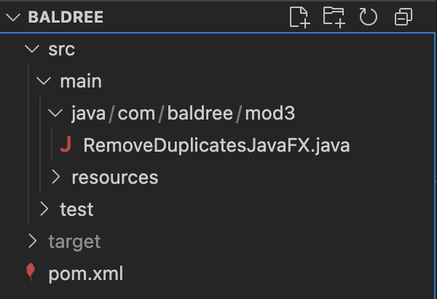

Output:
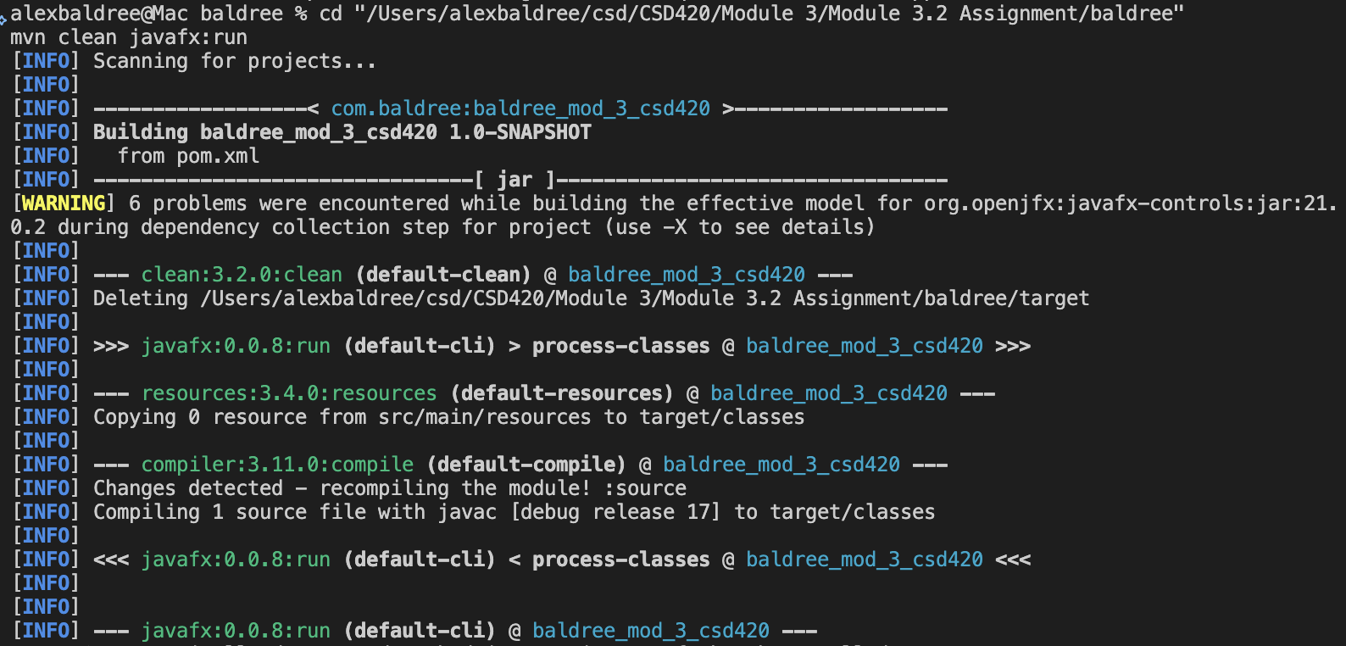

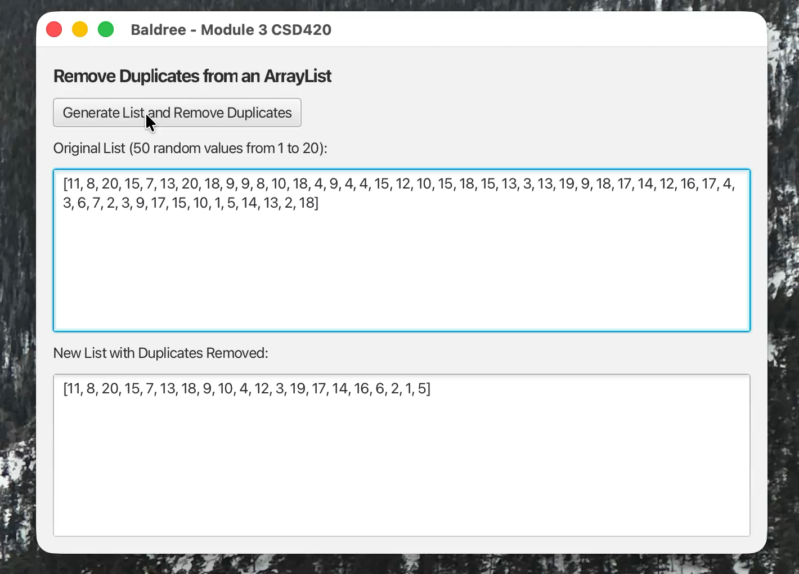
Program Output in Java: (Right Click- Play)

